Project Design Phase-II
Technology Stack (Architecture & Stack)

Date | 30 September 2026
Team ID | SWTID-2026-8886
Project Name | Implement Client Script and UI Policy for Incident
Maximum Marks | 4 Marks

Technical Architecture:
The Deliverable shall include the architectural diagram as below and the information as per the table1 & table 2
Example: Incident form and client-control flow.
Reference: https://developer.ibm.com/patterns/ai-powered-backend-system-for-order-processing-during-pandemics/
Guidelines:
Include all the processes (As an application logic / Technology Block)
Provide infrastructural demarcation (Local / Cloud)
Indicate external interfaces (third party API’s etc.)
Indicate Data Storage components / services
Indicate interface to machine learning models (if applicable)
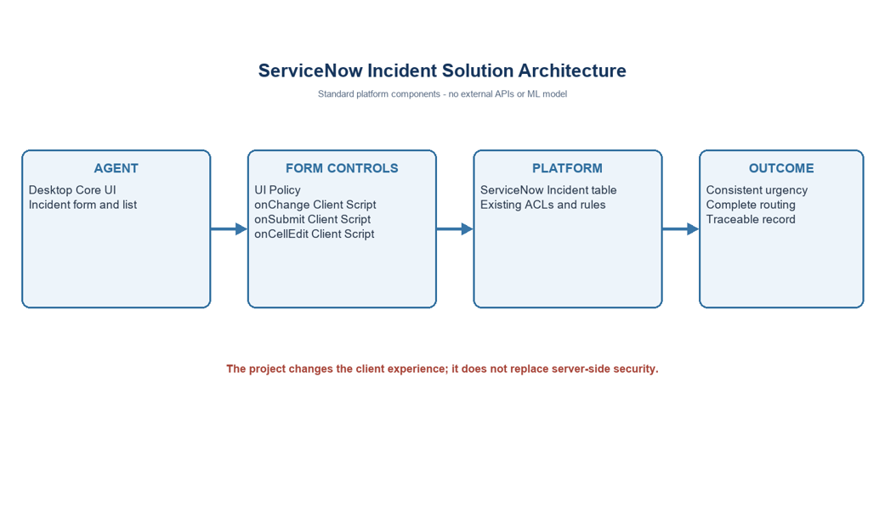

Table-1 : Components & Technologies:
S.No | Component | Description | Technology
1 | User interface | Desktop Incident form and list | ServiceNow Core UI
2 | Policy logic | Conditional mandatory/read-only behavior | Incident UI Policy
3 | Change logic | Set Urgency High when Impact becomes High | onChange Client Script
4 | Save validation | Check group and assignee at submit | onSubmit Client Script
5 | List behavior | Decline direct State edit in list | onCellEdit Client Script
6 | Data store | Incident records and standard fields | ServiceNow Incident table
7 | Cloud database | No separate database configured | Platform-managed storage
8 | File storage | No new file storage | Not applicable
9 | External API 1 | No external API used | Not applicable
10 | External API 2 | No external API used | Not applicable
11 | ML model | No machine learning used | Not applicable
12 | Infrastructure | Existing ServiceNow instance | Platform managed

Table-2: Application Characteristics:
S.No | Characteristics | Description | Technology
1 | Open source framework | No separate framework introduced | Native platform
2 | Security controls | Existing ACLs remain; client rules are not security boundary | ACL/Data Policy/Business Rule as required
3 | Scalable architecture | No new service or data store | Existing instance
4 | Availability | Depends on instance availability | No additional dependency
5 | Performance | Client logic, no external API | Measure in test instance

References:
https://c4model.com/
https://developer.ibm.com/patterns/online-order-processing-system-during-pandemic/
https://www.ibm.com/cloud/architecture
https://aws.amazon.com/architecture
https://medium.com/the-internal-startup/how-to-draw-useful-technical-architecture-diagrams-2d20c9fda90d

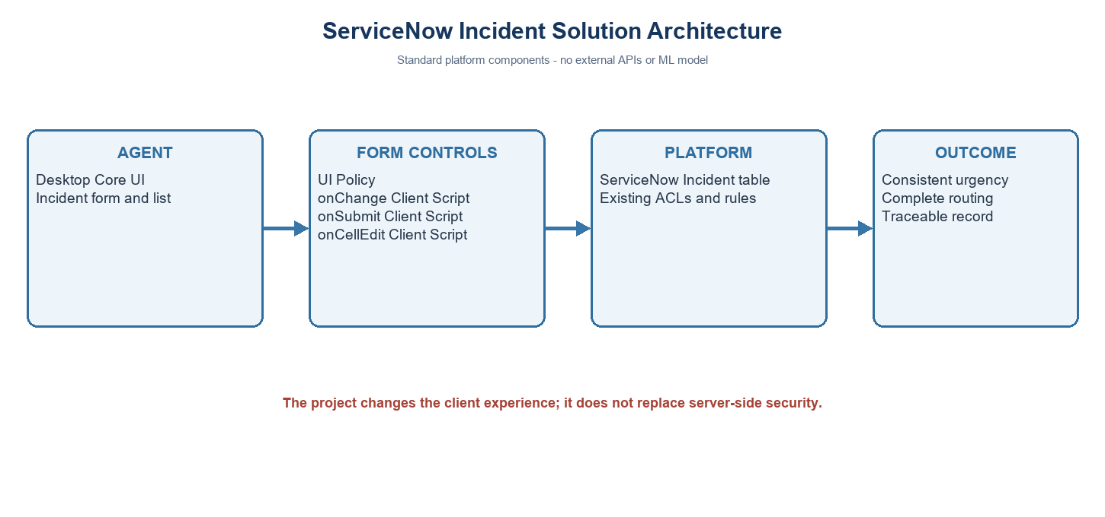
ServiceNow platform context
Project note: values use the standard Incident choices where Impact 1 and Urgency 1 represent High. Confirm field names and values in the target instance.

